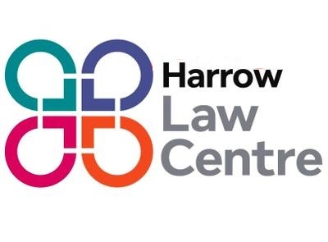

**Solicitor – Housing**

**35 hours per week (part time considered)**

**Salary £48,963 per annum plus pension**

**Location Hybrid - Harrow/home working**

**Deadline: Noon Wednesday 9th October 2024**

Harrow Law Centre is a forward-thinking Law Centre which provides specialist legal advice and representation to combat disadvantage, discrimination and exclusion. It has an excellent reputation and was shortlisted both in 2024 and 2017 by the Legal Aid Practitioners Group for an award as the Legal Aid Firm of the year.

We are seeking a housing solicitor to join our housing team. You will have the opportunity to work on a range of housing matters including defending possession proceedings and judicial reviews. In addition you will have the opportunity to work alongside our housing campaigns worker in a combination of campaigns and strategic legal work.

We hold legal aid contracts in Crime, Education, Housing, Immigration/Asylum, Public Law and Welfare Benefits. However in response to the demands from the community we are looking at developing a new area of work at the Law Centre assisting residents challenge major developments and regeneration in the borough.

We are based in Harrow but we operate a hybrid system of working.